

Pathogen Tracker Game

Stage One: Declare an Outbreak

Level I Student Worksheet

Vocabulary: biodiversity, colony, contaminate, database, DNA, Escherichia coli O157:H7, foodborne illness, genetic fingerprint, isolate, Listeria monocytogenes, obtundation, outbreak, pathogen, Pathogen Tracker, PCR, phenotype, restriction enzyme, riboprint, ribosome, RNA, Salmonella, Southern blotting, species, strain, subspecies, zoonotic

BEFORE YOU BEGIN PLAYING THE GAME, please answer the following questions:

- What is a foodborne illness and why is it such a serious issue?

- What is a foodborne illness outbreak?

- List the steps you think scientists follow in finding the cause of a foodborne illness outbreak.

4. Once a cause for a foodborne illness outbreak has been declared, what do you think officials can do to protect the public’s health?

YOU ARE NOW READY TO PLAY THE GAME. As you play the game, answer the questions when you come to the appropriate page.

What are foodborne pathogens?

What symptoms were the patients with the suspected foodborne illness experiencing?

Create a table to record the symptoms of the following foodborne pathogens: Escherichia coli (E. coli) O157:H7, Listeria monocytogenes (L. monocytogenes), and Salmonella.

Which foodborne pathogen is responsible for the suspected foodborne illness outbreak? Be sure to give your detailed reasons for choosing this pathogen.

Describe in detail the steps to follow in making a riboprint.

Create a table to record the names of the patients who had the same riboprints, the date on which their symptoms first appeared, and the state in which they live.

What is Pathogen Tracker and how is it be used to track a foodborne illness outbreak?

When the screen shown on the right is reached, you should read the INSTRUCTIONS and then use the back button to return to the PT DATABASE. | 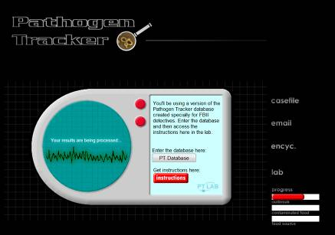

Explain in detail how the Pathogen Tracker database can be used to identify the strain of L. monocytogenes responsible for the foodborne illness outbreak.

Which strain of L. monocytogenes was identified as being present in the patients? Explain how you determined that the strain found in the patients was the same as a strain already in the Pathogen Tracker database?

What parameters are necessary in order for a foodborne illness outbreak to be declared?

Why is the first graph “Foodborne Illness Incidences Over the Last Five Months” not adequate to declare an outbreak and why is the second graph adequate?

Now that you have completed Stage One of Pathogen Tracker, return to question 3 at the beginning of this worksheet and review the steps you listed. What revisions, if any, would you make to these steps? Be sure to explain why you are making these revisions.

Password to go onto Stage Two: Find the Contaminated Food: __________________

